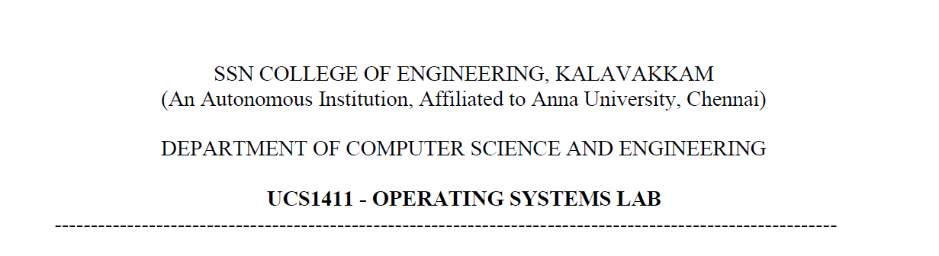

**NETWORKS LAB**

**EXERCISE 10**

Name: Jayannthan P T

Dept: CSE ‘A’

Roll No.: 205001049

Simulation of Routing protocol

**Aim:**

Write tcl script to simulate the routing protocols in wired networks.

**Code:**

**Distance Vector Routing Protocol**

set ns [new Simulator]

$ns color 1 Blue

$ns color 2 Red

set nf [open out.nam w]

$ns namtrace-all $nf

proc finish {} {

    global ns nf

    $ns flush-trace

    close $nf

    exec nam out.nam &

    exit 0

}

set n(0) [$ns node]

set n(1) [$ns node]

set n(2) [$ns node]

set n(3) [$ns node]

set n(4) [$ns node]

set n(5) [$ns node]

set n(6) [$ns node]

set n(7) [$ns node]

set n(8) [$ns node]

set n(9) [$ns node]

set n(10) [$ns node]

set n(11) [$ns node]

for {set i 0} {$i < 8} {incr i} {

$ns duplex-link $n($i) $n([expr $i+1]) 1Mb 10ms DropTail }

$ns duplex-link $n(0) $n(8) 1Mb 10ms DropTail

$ns duplex-link $n(1) $n(10) 1Mb 10ms DropTail

$ns duplex-link $n(0) $n(9) 1Mb 10ms DropTail

$ns duplex-link $n(9) $n(11) 1Mb 10ms DropTail

$ns duplex-link $n(10) $n(11) 1Mb 10ms DropTail

$ns duplex-link $n(11) $n(5) 1Mb 10ms DropTail

$ns duplex-link-op $n(0) $n(1) orient right-down

$ns duplex-link-op $n(1) $n(2) orient right-down

$ns duplex-link-op $n(2) $n(3) orient down

$ns duplex-link-op $n(3) $n(4) orient left-down

$ns duplex-link-op $n(4) $n(5) orient left-down

$ns duplex-link-op $n(5) $n(6) orient left-up

$ns duplex-link-op $n(6) $n(7) orient left-up

$ns duplex-link-op $n(7) $n(8) orient up

$ns duplex-link-op $n(8) $n(0) orient right-up

$ns duplex-link-op $n(11) $n(5) orient up

$ns duplex-link-op $n(9) $n(11) orient right

$ns duplex-link-op $n(10) $n(11) orient left

set udp1 [new Agent/UDP]

$ns attach-agent $n(0) $udp1

set null [new Agent/Null]

$ns attach-agent $n(5) $null

$ns connect $udp1 $null

$udp1 set fid_ 1

set udp2 [new Agent/UDP]

$ns attach-agent $n(1) $udp2

set null [new Agent/Null]

$ns attach-agent $n(5) $null

$ns connect $udp2 $null

$udp2 set fid_ 2

set cbr1 [new Application/Traffic/CBR]

$cbr1 attach-agent $udp1

$cbr1 set type_ CBR

$cbr1 set packet_size_ 1000

$cbr1 set rate_ 1mb

$cbr1 set random_ false

set cbr2 [new Application/Traffic/CBR]

$cbr2 attach-agent $udp2

$cbr2 set type_ CBR

$cbr2 set packet_size_ 1000

$cbr2 set rate_ 1mb

$cbr2 set random_ false

$ns rtproto DV

$ns rtmodel-at 1.0 down $n(11) $n(5)

$ns rtmodel-at 2.0 down $n(7) $n(6)

$ns rtmodel-at 2.0 up $n(11) $n(5)

$ns rtmodel-at 3.0 up $n(7) $n(6)

$ns at 0.1 "$cbr1 start"

$ns at 0.2 "$cbr2 start"

$ns at 4.5 "$ns detach-agent $n(0) $udp1 ; $ns detach-agent $n(5) $null ; $ns detach-agent $n(1) $udp2"

$ns at 5.0 "finish"

$ns run

**Output:**

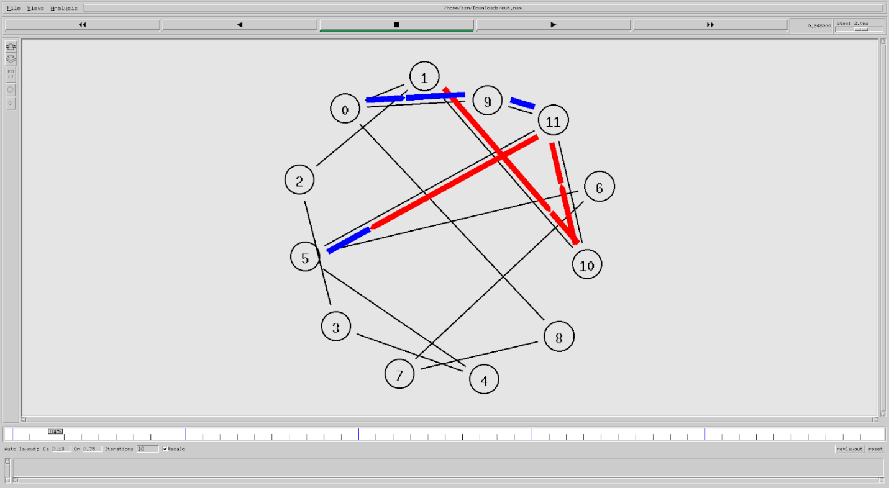

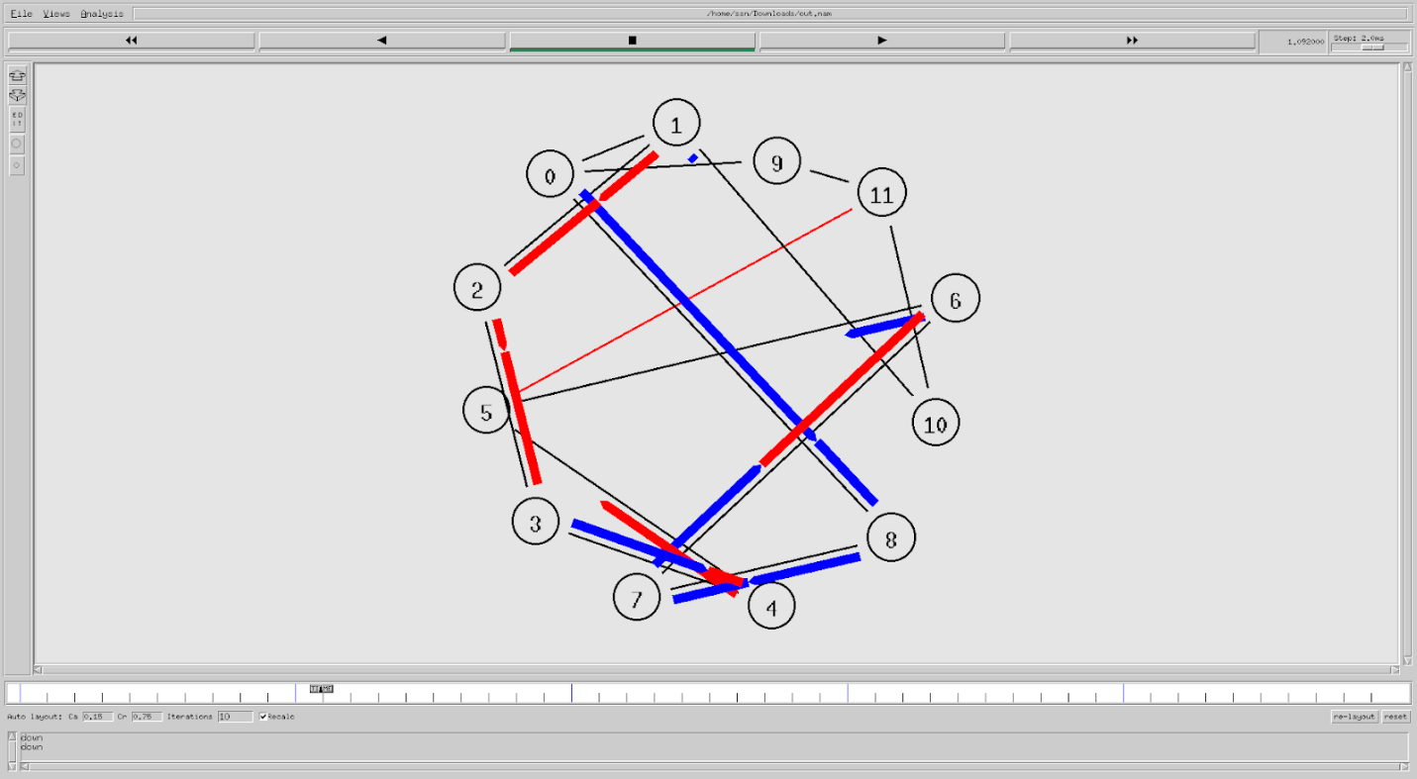

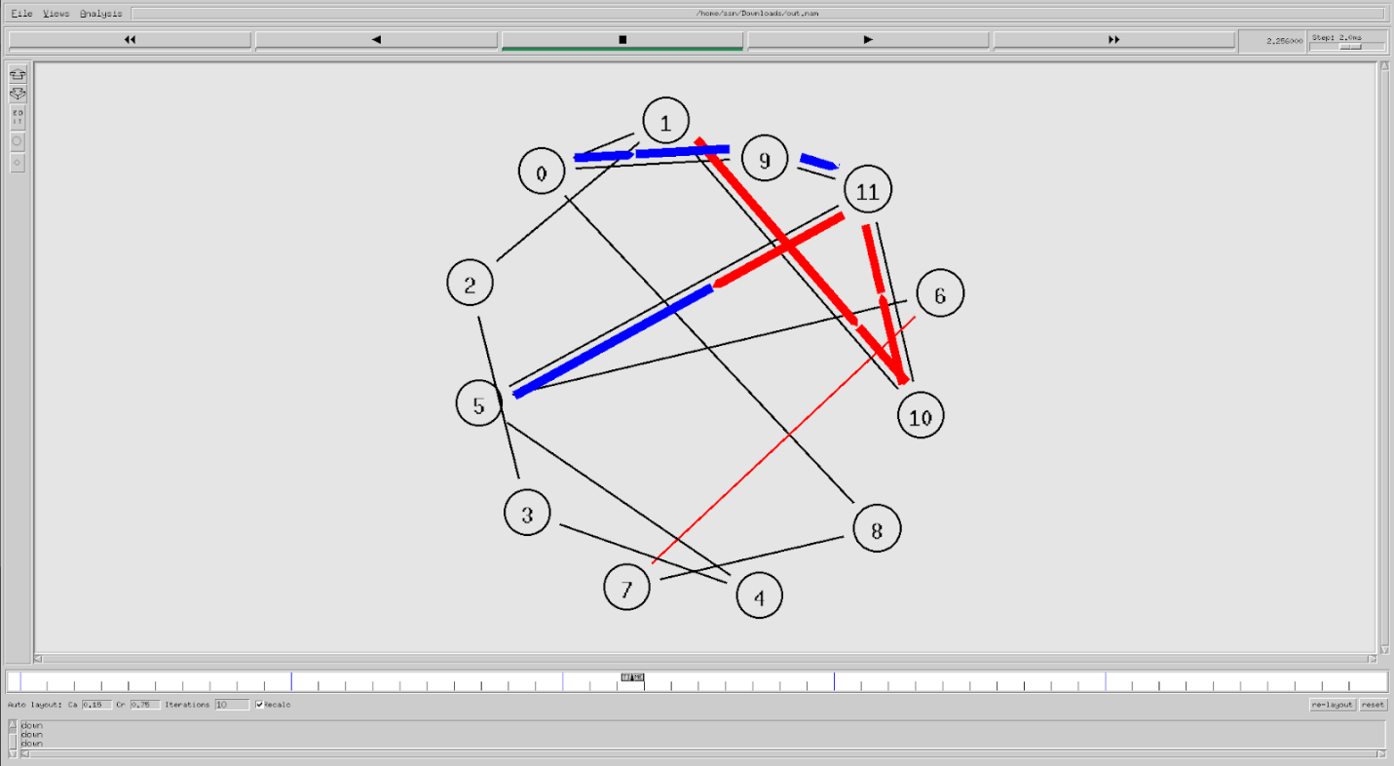

**Code:**

**Link State Routing Protocol**

set ns [new Simulator]

$ns color 1 Blue

$ns color 2 Red

set nf [open out.nam w]

$ns namtrace-all $nf

proc finish {} {

    global ns nf

    $ns flush-trace

    close $nf

    exec nam out.nam &

    exit 0

}

set n(0) [$ns node]

set n(1) [$ns node]

set n(2) [$ns node]

set n(3) [$ns node]

set n(4) [$ns node]

set n(5) [$ns node]

set n(6) [$ns node]

set n(7) [$ns node]

set n(8) [$ns node]

set n(9) [$ns node]

set n(10) [$ns node]

set n(11) [$ns node]

for {set i 0} {$i < 8} {incr i} {

$ns duplex-link $n($i) $n([expr $i+1]) 1Mb 10ms DropTail }

$ns duplex-link $n(0) $n(8) 1Mb 10ms DropTail

$ns duplex-link $n(1) $n(10) 1Mb 10ms DropTail

$ns duplex-link $n(0) $n(9) 1Mb 10ms DropTail

$ns duplex-link $n(9) $n(11) 1Mb 10ms DropTail

$ns duplex-link $n(10) $n(11) 1Mb 10ms DropTail

$ns duplex-link $n(11) $n(5) 1Mb 10ms DropTail

$ns duplex-link-op $n(0) $n(1) orient right-down

$ns duplex-link-op $n(1) $n(2) orient right-down

$ns duplex-link-op $n(2) $n(3) orient down

$ns duplex-link-op $n(3) $n(4) orient left-down

$ns duplex-link-op $n(4) $n(5) orient left-down

$ns duplex-link-op $n(5) $n(6) orient left-up

$ns duplex-link-op $n(6) $n(7) orient left-up

$ns duplex-link-op $n(7) $n(8) orient up

$ns duplex-link-op $n(8) $n(0) orient right-up

$ns duplex-link-op $n(11) $n(5) orient up

$ns duplex-link-op $n(9) $n(11) orient right

$ns duplex-link-op $n(10) $n(11) orient left

set tcp1 [new Agent/TCP]

$ns attach-agent $n(0) $tcp1

set sink [new Agent/TCPSink]

$ns attach-agent $n(5) $sink

$ns connect $tcp1 $sink

$tcp1 set fid_ 1

set tcp2 [new Agent/TCP]

$ns attach-agent $n(1) $tcp2

set sink [new Agent/TCPSink]

$ns attach-agent $n(5) $sink

$ns connect $tcp2 $sink

$tcp2 set fid_ 2

set cbr1 [new Application/Traffic/CBR]

$cbr1 attach-agent $tcp1

$cbr1 set type_ CBR

$cbr1 set packet_size_ 1000

$cbr1 set rate_ 1mb

$cbr1 set random_ false

set cbr2 [new Application/Traffic/CBR]

$cbr2 attach-agent $tcp2

$cbr2 set type_ CBR

$cbr2 set packet_size_ 1000

$cbr2 set rate_ 1mb

$cbr2 set random_ false

$ns rtproto DV

$ns rtmodel-at 1.0 down $n(11) $n(5)

$ns rtmodel-at 2.0 down $n(7) $n(6)

$ns rtmodel-at 2.0 up $n(11) $n(5)

$ns rtmodel-at 3.0 up $n(7) $n(6)

$ns at 0.1 "$cbr1 start"

$ns at 0.2 "$cbr2 start"

$ns at 4.5 "$ns detach-agent $n(0) $tcp1 ; $ns detach-agent $n(5) $sink ; $ns detach-agent $n(1) $tcp2"

$ns at 5.0 "finish"

$ns run

**Output:**

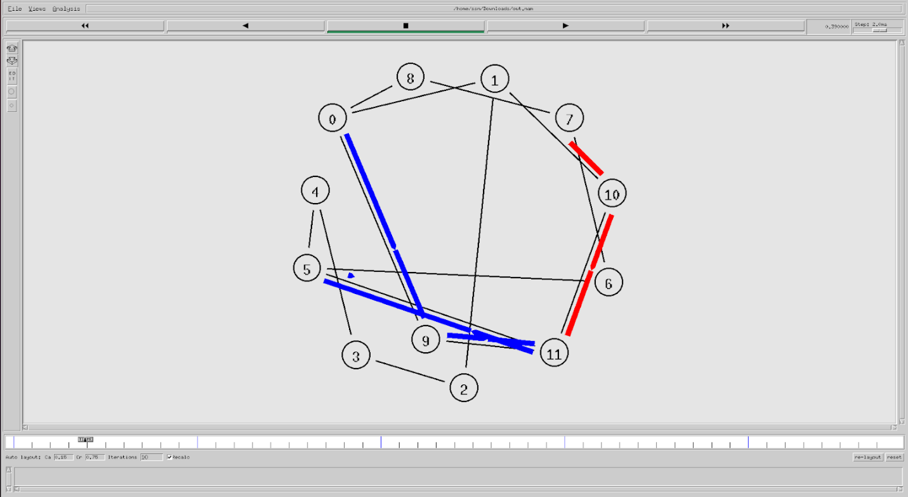

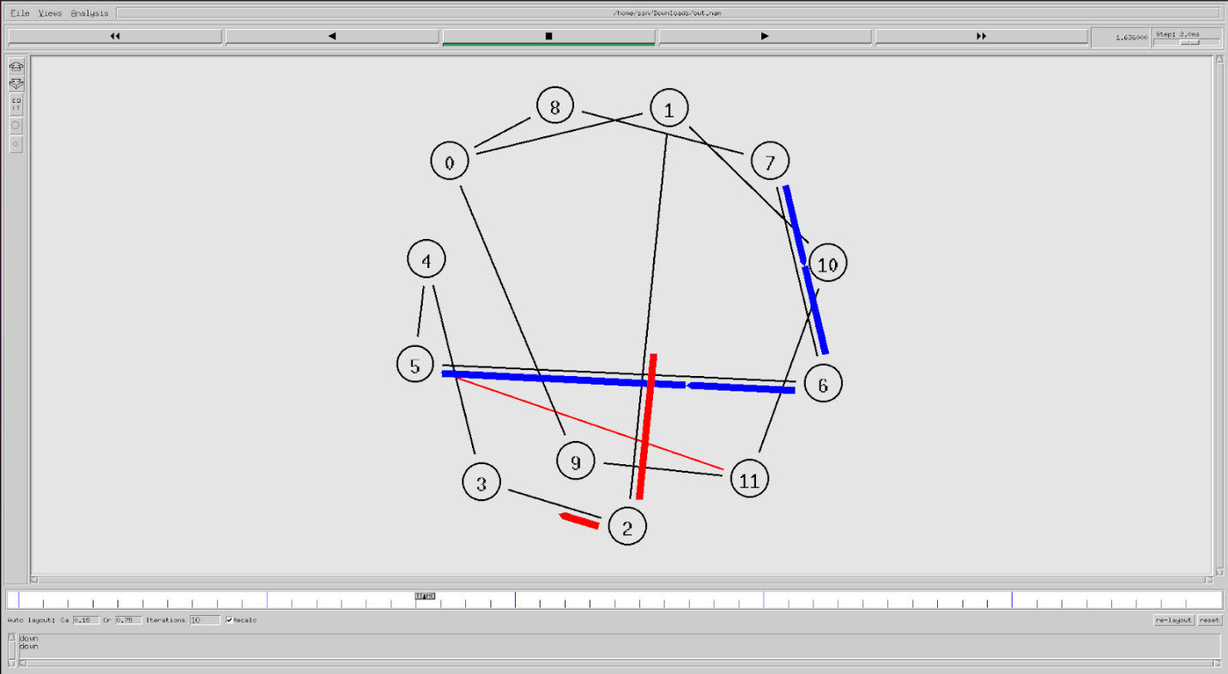

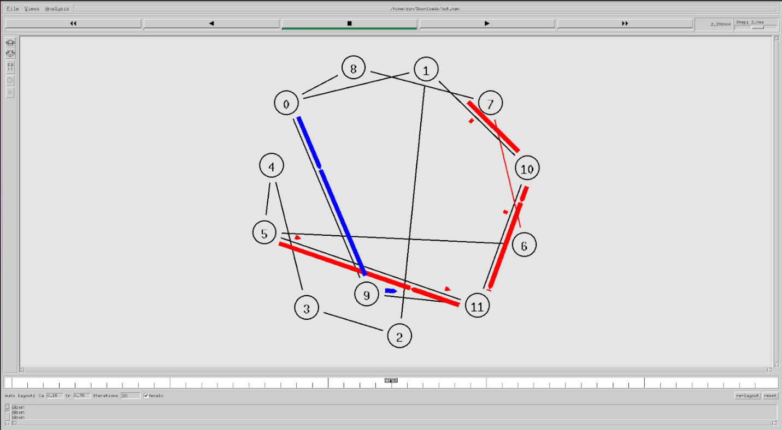

**Learning outcome:**

Learnt to implement simulate the simulate the routing protocols in wired networks.